The Common Format
This section presents our work towards a joint format for a suite of analysis tools, so that the rich raw data of diverse learning environments can be analysed with a variety of analysis tools.

Introduction
Providing a common format usable with a variety of analysis tools addresses the fact that a lot of the current analysis tools are tightly bound to the specific learning support application. This reduces the re-usability for analysis in different contexts immensely, as can be seen in figure XX with a schematic overview of the project partners’ tools used for this project.
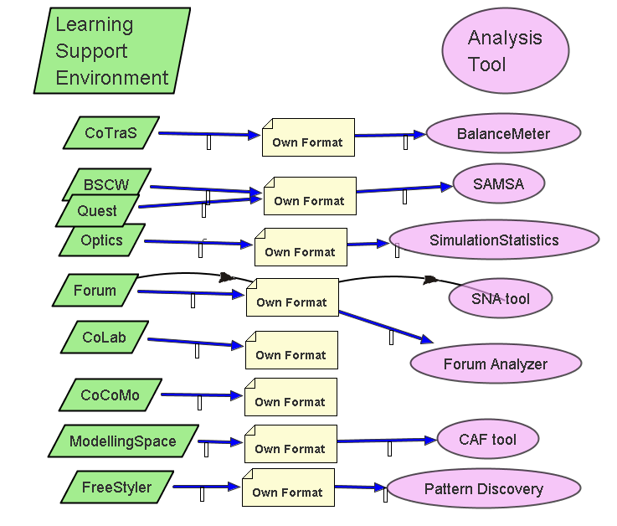Figure XX: The initial situation – analysis tools tightly bound to learning environments

The description template is meant to explain to the potential users of analysis tools the usage and context of a specific analysis tool. This alone does not allow to use the tool in a flexible way, since the tool ist still bound to a proprietary input format created by the specific learning environment.

As a step to complement the conceptual integration underlying the description template with a technical integration and interoperability between learning environments and tools, we have worked towards a joint format usable by the partners’ available analysis tools. This common format facilitates the workpackage’s idea of defining a library of tools that can be used for a variety of different purposes of analysis. This idea of having one format that is produced by all the learning support environments of the project and that is consumed by all the analysis tools that can be used in different contexts is visualized in figure XY.

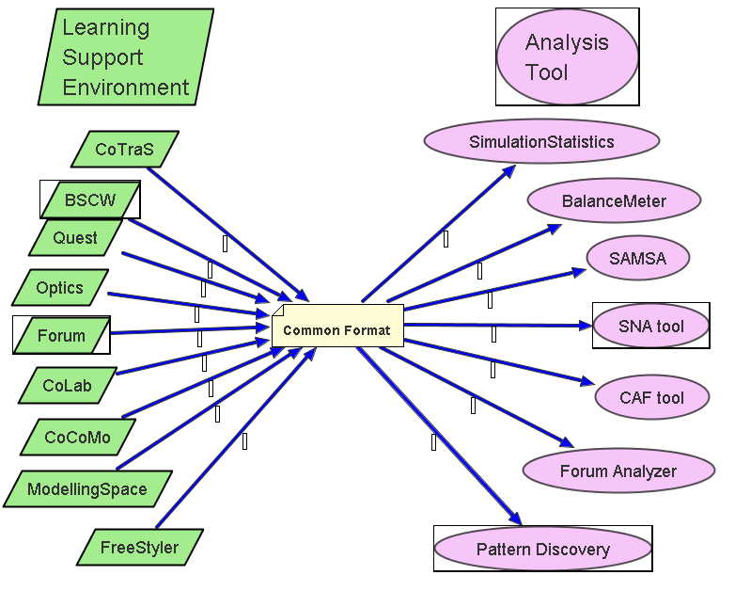
Figure XY: The desired solution – analysis tools decoupled from specific learning environments

In our project meeting in Valladolid in February we organised the partners’ available analysis tools according to their degree of binding with a specific learning environment. This can be seen in figure XZ. Some of the tools, especially the ones used for on-the-fly feedback in the learning environment were tightly bound to that system. Thus they either were no candidates for the library of reusable tools or have to be extracted as well-defined and more loosely-coupled components. So our main candidates for a practical re-use in different contexts were the tools in the upper right quadrant of the figure.
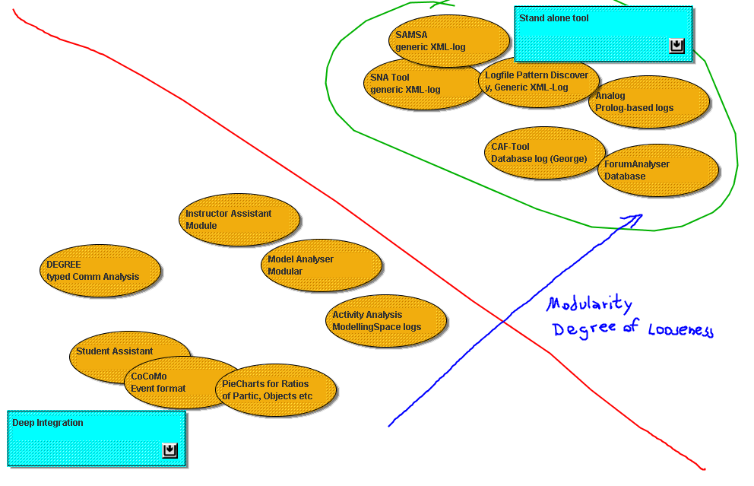
Figure XZ: Organisation of existing tools according to their re-usability and degree of coupling with specific environments

Based on initial work on explicit representation of user actions in XML-representations in some teams (Gaßner, Jansen, Harrer, Herrmann, Hoppe, 2003) (Martinez, De la Fuente, Dimtriadis, 2003) (Harrer, Vetter, Thür, Brauckmann, 2005) a structured format using XML was chosen as the basis for the common format. Intensive discussion and a dedicated workpackage workshop in Duisburg in April led to drafts of the elements of the common format and a finalised version by begin of July 2005. Details of the representation will be described in the following section.

Description of the Format
Defining a common format is influenced by two competing desiderata: on the one hand it has to be well-defined and structured, on the other hand it must be flexible enough to allow additional information created by specific learning environments, which might be useful for some analysis techniques. Thus the challenge was to define a reliable common denominator for the minimally required information, while providing a mechanism to mix in important features in a flexible way. This is reflected in the required and optional elements of our Document Type Description (DTD) for the Common Format.
The required elements are based on our previous approaches and experiences and also other approaches described in the literature (Avouris, Dimitracpulou, Komis, 2003). As most important information captured for analytic purposes in potentially collaborative scenarios we see:

- Action type: a description of the precise type of action according to the typology used within the learning environment. For more general categories an attribute “classification” is available with standard categories, such as read/write/modify etc.
- User: for collaboration analysis we need information about the actors involved in the action and the roles assumed by them with respect to the action, such as originator and recipient of the action
- Time: a timestamp that allows ordering and measuring intervals of the captured information traces.

An optional object can be specified, since most user actions target object(s), especially in environments with Direct Manipulation interfaces. The object description can be enriched as needed by properties, such as the object’s attributes and associated values. This provides a very flexible mechanism, but on the backside it lacks the strictness of definition that would be needed to check at a general level if all needed elements for some specific analysis are available.

Usually a description of the general setup of a learning situation, such as participants, formal roles of the participants, subgroups, external resources available and so on, help to understand the scenario and the analysis processes suited for it. Consequently we added a section called “PREAMBLE” that provides the information to define the learning scenario.

A graphical overview of the elements and attributes in the common format is represented in figure Xa. The full version of the DTD can be found in the appendix.

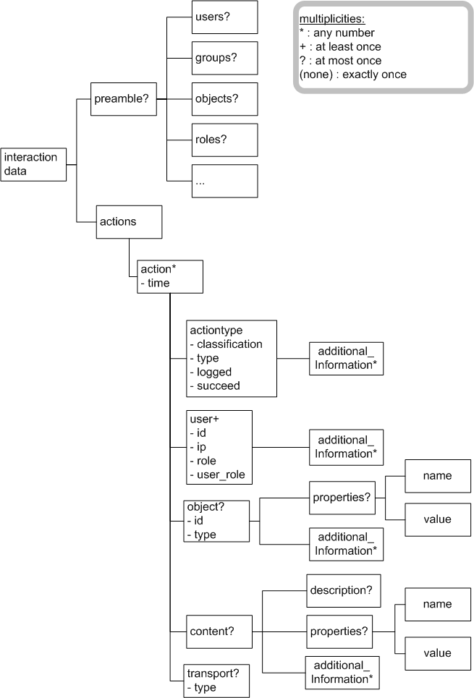

Figure Xa: Diagram of the DTD of the Common Format. For reasons of readability, this diagram does not show the complete DTD.

As a general comment the common format is meant to be a flexible representation preserving the data of all the potential input format. To achieve this we had to declare a lot of elements as optional. This makes the checking of integrity of documents more complicated than with a fixed structure of elements, but this cannot be helped because of the potential difference in information richness of the original input formats. On the other hand not all information needed by some analysis tools can be enforced by the common format (e.g. links between postings are neccessary for SNA and posting pattern analysis). As a means to cope with this in some cases the information needed by an analysis tool could be derived by additional scripts/preprocessors in intermediate steps; all the intermediate products should use the common format to enable analysis chains and multiple analyses for each step.

Practical Use
To put our common format approach to practice with existing learning environments and tools there are different options for realization with respect to touching the existing code. Ideally each of our learning environments should produce the common format while each of the analysis tools accepts this common format as the input for analysis (cf. figure XY, and figure Xb from lower left to upper right side).
Yet there were some pragmatic issues that made a reflection about alternatives neccessary: A modification of the existing code is in some cases awkward to achieve because of potentially very different code segments affected by the modification; for additional applications without our project usually the code of the application is not available at all, which makes it unfeasible to let the application itself produce the common format.
The alternative is to use the learning environment as it is, with the output it produces originally, and to define a mapping from this proprietary output format to the common format. With an exact conceptual mapping the definition of an appropriate XSL transformation or other means of tranformation (such as an intermediary object structure written out as common format XML) can be implemented. This approach can be seen in the upper left branch of figure Xb
Similar arguments can be raised for analysis tools whether accepting input in the common format or in the original one. For some analysis tools touching the code to accept the common format seemed to cause more effort (figure Xb upper right) than defining a mapping and making a format transformation (figure Xb lower right).
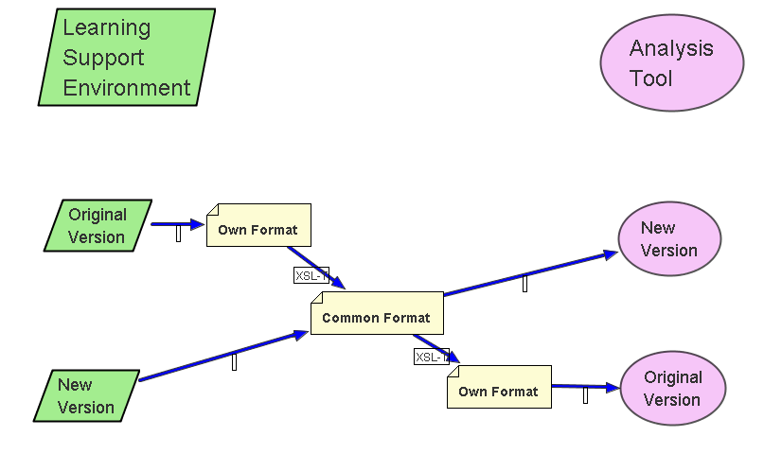
Figure Xb: Different modes of using the common format with learning environments and analysis tools

In the Duisburg meeting we discussed for every tool, that eventually will be part of the tool library, which procedure to choose to use the common format. We agreed that for every newly developed learning environment and analysis tool the direct use of the common format will be mandatory for the partners. For existing environments and tools the owner discussed with the partners the preferrable option of handling the common format. For some of the systems the code modifications were not considered a problem, while for some other applications the transformations were chosen. In the end we collected experience with all the different variants, to give some examples:
- The export from a discussion forum (that holds the postings in a database) was realized directly to the common format to be used by arbitrary analysis tools.
- The DIAS (Discussion Interaction Analysis System) and the PatternDiscovery tool (Harrer, Vetter, Thür, Brauckmann, 2005) were modified to accept the common format as input.
- For the data that is used by the SAMSA tool (Reference??) with an XML-based format, both the transformation to the common format to allow other analyses and the transformation from the common format to the SAMSA format was realized, to make SAMSA usable with input from different learning environments.

The interoperability achieved by means of the common format was tested recently by analysing the discussion forum logs of the Aegean partners (provided in the common format) with the PatternDiscovery analysis tool (accepting the common format). Further testing will be conducted for each system or transformer compliant to the common format to guarantee interoperability between all the systems of the “Common Format Tool Library”.

Appendix: Document Type Definiton (DTD) of the Common Format

<?xml version="1.0" encoding="UTF-8"?>
<!-- common format describing input-data for analysis tools -->

<!-- general root-element for the document -->
<!ELEMENT interactiondata (preamble?, actions)>

<!ELEMENT preamble (users?, groups?, objects?, roles?, conditions?, document_information?, time_range?, description?, additional_information*)>

<!ELEMENT users (user_def*)>

<!ELEMENT user_def (description?)>
<!ATTLIST user_def id ID #REQUIRED>
<!ATTLIST user_def firstname CDATA #REQUIRED>
<!ATTLIST user_def lastname CDATA #IMPLIED>
<!ATTLIST user_def role CDATA #IMPLIED>

<!ELEMENT groups (group_def*)>

<!ELEMENT group_def (time_range?, description?)>
<!ATTLIST group_def id ID #REQUIRED>
<!ATTLIST group_def members CDATA #REQUIRED>

<!ELEMENT objects (object_def*)>

<!ELEMENT object_def (description?, properties?, additional_information*)>
<!ATTLIST object_def type CDATA #REQUIRED>
<!ATTLIST object_def id ID #REQUIRED>

<!ELEMENT roles (role_def*)>

<!ELEMENT role_def (description)>
<!ATTLIST id ID #REQUIRED>

<!ELEMENT conditions (instructions?, description?)>
<!ATTLIST conditions creator_application CDATA #IMPLIED>
<!ATTLIST conditions application_version CDATA #IMPLIED>
<!ATTLIST conditions experimenter CDATA #IMPLIED>

<!ELEMENT instructions (instruction*)>

<!ELEMENT instruction (PCDATA)>
<!-- maybe some document-link, or some free text -->

<!ELEMENT time_range EMPTY>
<!ATTLIST time_range from CDATA #REQUIRED>
<!ATTLIST time_range to CDATA #REQUIRED>

<!-- root element for action-description -->
<!ELEMENT actions (action*)>

<!-- any action that is to be analyzed -->
<!ELEMENT action (actiontype, user+, object?, content?, transport?)>
<!ATTLIST action time CDATA #REQUIRED>

<!-- description of the action itself -->
<!-- classfication: a general classification, other for anything that does not fit into the classification, intendend for hand-edited actions, not for logged ones -->
<!-- type: more specific description, in case of logged actions the description used in the original environment -->
<!-- logged: describes if the action is autoimatically logged or hand-edited -->
<!ELEMENT actiontype (additional_information*)>
<!ATTLIST actiontype classification (create | delete | read | write | move | modify | other) #REQUIRED>
<!ATTLIST actiontype type CDATA #REQUIRED>
<!ATTLIST actiontype logged (true | false) #REQUIRED>
<!ATTLIST actiontype succeed (true | false) #IMPLIED>

<!-- description of users involved into the action -->
<!-- role: at least one originator is to be given -->
<!ELEMENT user (additional_information*)>
<!ATTLIST user id CDATA #REQUIRED>
<!ATTLIST user ip CDATA #IMPLIED>
<!ATTLIST user role (originator | receiver) #REQUIRED> <!-- this reflects the role with respect to sending or receiving messages -->
<!ATTLIST user user_role CDATA #IMPLIED> <!-- this reflects the role the user plays within the group, e.g. teacher, student, tutor, ... -->

<!ELEMENT object (properties?, additional_information*)>
<!ATTLIST object id CDATA #REQUIRED>
<!ATTLIST object type CDATA #REQUIRED>

<!ELEMENT content (description?, properties?, additional_information*)>

<!ELEMENT properties (property*)>

<!ELEMENT property EMPTY>
<!ATTLIST property name CDATA #REQUIRED>
<!ATTLIST property value CDATA #REQUIRED>

<!ELEMENT transport ANY>
<!ATTLIST transport type CDATA #REQUIRED>

<!-- space for saving any kind of information wanted in the file, that is not covered anywhere else -->
<!ELEMENT additional_information ANY>
<!ATTLIST additional_information type CDATA #REQUIRED>

<!-- space for a human-readable description -->
<!ELEMENT description (#PCDATA)>

